GREEN HILL PRESBYTERIAN CHURCH
2018 MISSION STUDY REPORT
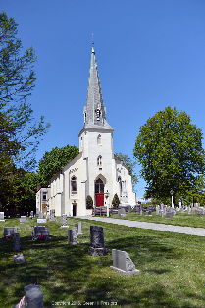
3112 KENNETT PIKE
WILMINGTON, DE 19807
WWW.GREENHILLPRES.ORG

TABLE OF CONTENTS

Mission Study Team 3
Our Vision, Mission, Values, and Goals 4
Introduction 5
Worship and Attendance 5
Membership 6
Music Ministry 6
Education 7
Mission Engagement 8
Other Programs and Activities 11
Our Boards, Committees and Staff 13
Description of Parish Area 14
Our Community 14
Our History and Property 14
Technology 17
Financial Sustainability 17
Conclusion 18

Appendix
2017 Green Hill Mission Engagement 19
2017 and 2016 Annual Reports

Note: Most of the photographs in this document were taken by John Hartman.

MISSION STUDY TEAM
Allison Brokaw
Kathy Dugan
Ellen Grubbs
John Hartman
Chick Reed

Rev. Tom Speers, Interim Pastor
Rev. Jenny Warren, Presbytery Liaison
Diane Shorter, Staff Support

The Mission Study Team is grateful for the insightful comments and input received from Green Hill’s members during the drafting of this document.

GREEN HILL PRESBYTERIAN CHURCH
OUR VISION
Green Hill Presbyterian Church seeks a vibrant faith in Christ through adherence to Scripture and joyous traditional worship, demonstrating Christ’s love through fellowship, practical outreach and mission.
OUR MISSION
As humble disciples of Jesus Christ, our mission is to worship the Lord, learn and understand His holy word, encourage and demonstrate the love of God, and utilize our talents to God’s service.
OUR VALUES
We reaffirm three major tenets of our historic confessions and constitution:
- That Jesus Christ alone is Lord of all and the Way of salvation.
- That Holy Scripture is the Triune God’s revealed Word, the Church’s only infallible rule of faith and life.
- That God’s people are called, by the grace of God, to holiness in all aspects of life.
OUR GOALS
- Continue to grow in our faith through opportunities for learning and understanding God’s word and to nurture children and youth in their spiritual journey.
- Fulfill our responsibility of stewardship for God’s glory through service and support of our mission efforts and activities, including efforts to maintain and upgrade our facility.
- Continue our outreach initiatives.
- Attract new and active members into the life and faith of Green Hill.

INTRODUCTION
We believe Green Hill’s mission and values reflect our passion to know God’s word and walk in His paths. We hope you will sense the warmth of Green Hill and find the following pages informative and woven together with Green Hill’s belief that the Church’s one foundation is Jesus Christ. We are a heathy, growing church with a strong focus on Sunday worship, Christian education, and mission activities, supplemented with an active music program.

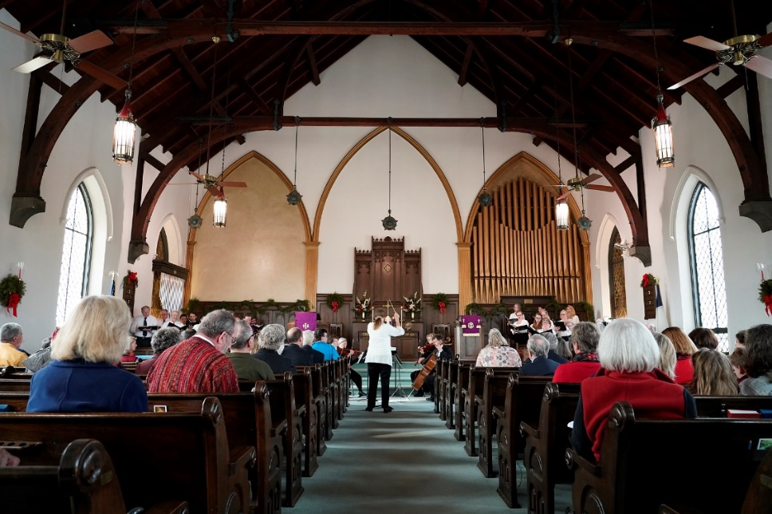

WORSHIP AND ATTENDANCE
The Sunday service is traditional. Many participate in the service - pastor, acolyte, beadle/reader and choir. There is a children’s message with youth participation and a range of ages from toddler to nine. Music is an important element of every service, and it is well-integrated into the program.
In addition to regular Sunday worship, special evening services are held on Maundy Thursday and Christmas Eve. We participate with three other local churches in a pre-Thanksgiving service, which takes place at each church on a rotating basis.
Sunday worship attendance is shown in the chart on the next page. In 2017 our highest attendance was 110, and the lowest 26; summer attendance is typically lower than the rest of the year. Recently we are seeing an increase in the number of visitors in Sunday worship.

MEMBERSHIP
Membership statistics are shown above, and we are delighted that since 2015 our net membership has increased 13%. Recent new members have quickly become active in our church life. At year-end 2017, membership of 81 consisted of 54 females and 27 males. Occupations include business professionals (legal, medical, financial, managerial), social workers, domestic partners, and retirees. Most of the membership has completed college, with many also post-graduate. A small number of members are within walking distance of the church, while most live within a two to five mile radius, and a small number beyond five miles.
Sunday worship attendance makeup largely mirrors membership composition. We typically have visitors each Sunday with the composition similar to our membership.

MUSIC MINISTRY
The music ministry at Green Hill is an important focus and an appreciated part of our worship service. The director of music and the pastor collaborate each week to select hymns and choral music which will complement the season, lectionary and sermon.
The church is proud to own a rebuilt Hook and Hastings pipe organ, a Schimmel grand piano and sets of Malmark hand bells, cymbells and hand chimes.
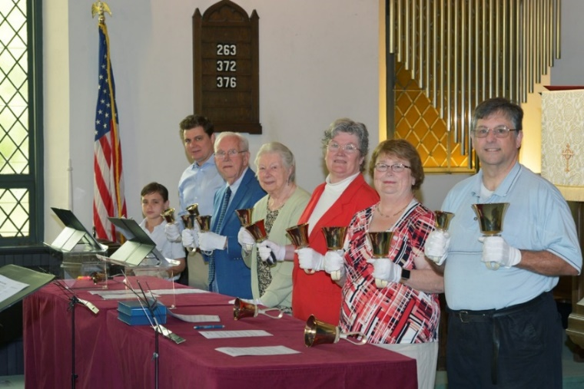
Green Hill’s choir is enthusiastic and sings a variety of choral music specifically selected for the group’s size and abilities, including spirituals, contemporary, folk, patriotic, and classical selections. Parishioners are also encouraged to share their vocal or instrumental talents using guitars, drums and tambourines. A children’s choir and two hand bell choirs provide music during selected services throughout the year. The bell choirs have brought together multi-generational participation.
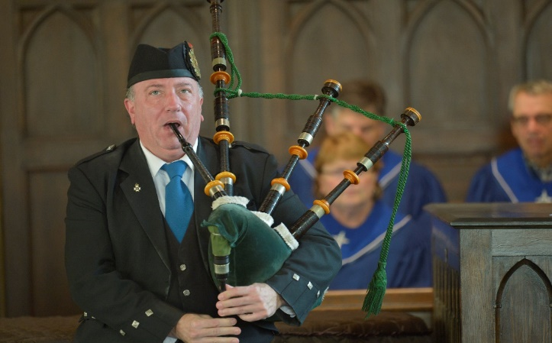
Professional instrumentalists or guest choirs are invited to participate during a service at least once a month. The variety of lovely music offered is enjoyed by the parishioners, and many have commented that the music program at Green Hill adds to their spirituality and time of reflection each Sunday. Guest musicians throughout the year include bagpiper, harpist, violinist, Capital Brass, trumpeter, etc.

Education
Christian Education
Green Hill Church is committed to providing educational opportunities to all-age parishioners to learn about the Bible, grow closer to God and strengthen personal faith. Green Hill provides a high level of interaction and individual attention.

Children and Middle School
Approximately 12 children, ranging in age from two years to sixth grade, are involved in our Sunday School program. The parish building provides two classrooms with capability to divide infants and pre-school children from the elementary students.
Most Sundays the children are combined into one classroom, as attendance can be inconsistent with a small enrollment. The teachers use the curriculum, Cokesbury One Room Sunday School. This curriculum has the advantage of offering flexible lesson plans suitable for all-age students grouped together. The students hear a weekly Bible message and participate in hands-on activities.
Two dedicated, long-time parishioners teach our children. Other church volunteers are scheduled and available to assist in the second classroom as needed. Safety is of upmost importance at Green Hill. Every volunteer is given a background check before being permitted to work with children.
Part of our children’s Christian education is their participation in worship. Prior to attending Sunday school, all children attend the first part of the service with their families and hear a children’s message given by the pastor.
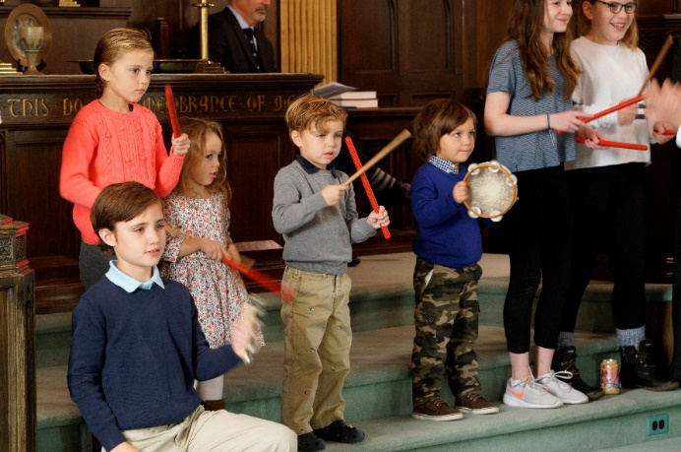
Children are invited to participate actively in the service, especially on Kids’ Sunday when children learn about and partake in Communion, sing, read from the Bible and collect the offering. On other Sundays, students will sing solos or sing as a group, or even play a hand bell with one of our adult bell choirs. All children are known and encouraged for who they are. They are God’s gifts to Green Hill.

High School/Young Adults
Green Hill currently does not offer a formal teen program, but our students are welcome to take part in our services and all the various activities we provide to adults. One high school student currently serves as a deacon and another has volunteered as a reader during the service. We are fortunate to have a collaborative relationship with Lower Brandywine Presbyterian Church in Greenville. Lower Brandywine has welcomed our teens to participate in their youth group, called LIFT, and in their youth choir. Looking to the future, our church would like to have an active youth program and attract more high school students to participate in our church life.

Adults
Bible study is important at Green Hill. The church offers three Bible study groups –lunchtime co-ed group, and men’s and women’s Bible studies. The women’s study is led by lay leaders, while other studies are led by the pastor. Attendance ranges from five to twelve per session.
Green Hill believes in the power of prayer and these gatherings are also used for group prayer for family, friends and others in need.

MISSION ENGAGEMENT
Green Hill Presbyterian Church has a long history of Mission work. Christian outreach is a vital focus of the church whether it is on the local level or globally. In 2017 5.5% of the operating budget was designated for missions ($12,400.00). Congregational support through special offerings provided an additional $6,851.00. The sum total of budget support and special offerings is one-tenth of revenue. In addition, countless volunteer hours, facility space and many other non-monetary items are donated and are not represented in mission contributions.

2017 Mission Engagement Summary

Note that Budgeted refers to the Mission Committee support through the operating budget, and Benevolence refers to other special offerings by the congregation. See Appendix for additional details regarding the Green Hill Mission support in 2017.

A quarter of Green Hill’s membership is actively involved in local Mission work. Through the generosity of members and friends’ time and offerings, the church has supported these organizations for many years. Green Hill’s Mission Committee presents to Session a budget proposal for mission outreach. The Deacons are also very instrumental in the selection and support to many of our local missions and special offerings. The congregation is kept informed about our mission efforts through The SPIRE monthly newsletter, announcements from the pulpit, Minutes for Mission, Mission breakfasts and write-ups in our weekly bulletins.

2017 Local Missions
A Door of Hope (www.adoorofhope.org) is a Christian faith-based pregnancy resource center. Green Hill provided support through the Mission budget and special offerings for the Baby Bottle Benefit.
Lutheran Community Services (LCS) (www.lcsde.org) assists low-income families with emergency food, housing and utility bills. Green Hill provided support through the Mission budget.
Mary Campbell Center (www.marycampbellcenter.org) is a residential long-term care facility for individuals with physical and intellectual disabilities. Green Hill provided support through a special offering.
Ministry of Caring (MOC) (www.ministryofcaring.org) is a nonprofit organization that provides a network of social, health and support services for those living in poverty, including the homeless and working poor, in the greater Wilmington, Delaware area. Through volunteer efforts, Green Hill Church actively supports the Emmanuel Dining Room (EDR), one of the many services provided by MOC. On the 19th of each month, there are eight volunteers from the church who prepare and deliver a hearty noontime meal to EDR. In addition Green Hill provided support to EDR through the Mission budget and a special offering. Other support to MOC consists of two clothing drives a year and the Adopt-A-Family program at Christmas time.
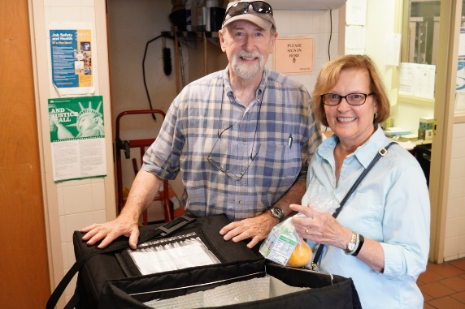
Meals on Wheels (www.mealsonwheelsde.org) is another organization where 15 Green Hill volunteers assist for a week every month in hand-delivery of hot, nutritious meals to homebound seniors.
Sunday Breakfast Mission (SBM) (www.sundaybreakfastmission.org) is located in downtown Wilmington and serves the homeless and addicted through Christ-centered programs. Green Hill provided support through the Mission budget and a special offering. In addition, school supplies are donated during the summer for the Back to School Rally, personal care items are donated for the Hope Tote Project, and nonperishable food items are collected year-round for the SBM Food Pantry, with a special emphasis at Thanksgiving time.
Urban Promise (www.urbanpromise.org) is an inner-city program committed to equip children and young adults with skills necessary for academic achievement, life management, personal growth and service leadership through the work of Christ. Green Hill provided support through the Mission budget.
Elsmere Fire Company (www.elsemerefc.com) is our local fire company. Green Hill provided support through the Mission budget.
AA and Al-Anon - Green Hill currently hosts eight AA and Al-Anon meetings in Fellowship Hall, serving more than 400 individuals on a weekly basis.
2017 National Missions
A special offering was collected for PCUSA Presbyterian Disaster Relief/Assistance after the impact of Hurricane Harvey. Another special collection was made for the Reverend Charles Gilmore Fund, which supported his daughter from the disaster of Hurricane Harvey.
The annual PCUSA Christmas Joy offering was collected.

2017 Global Missions
Green Hill supported four missionaries through the Mission budget: Jane Brooks and her work in Friends of Bangladesh, Dr. Reeta and Hari Rao with their work in Presbyterian Medical Benevolence, India and Keri Kondracki in her work with MANNA Worldwide.
A special offering was collected for PCUSA Mission Co-Workers Shelvis and Nancy Smith-Mather and their work with RECONCILE (Resource Center for Civil Leadership) in Uganda. This is an ecumenical Christian organization promoting “peace building.”
Care packages were sent overseas at Christmas time for our service personnel.
The annual PCUSA One Great Hour of Sharing was collected.

Other Programs and Activities
Community Outreach
Green Hill is actively involved in the greater community, and the pastor is a participant with many of these activities.
Our monthly newsletter, The SPIRE, is an excellent vehicle to share information about our church to members and friends as well as any visitors interested in knowing more about our church life.
The Craft Group meets throughout the year to create attractive, hand-crafted items to sell as a fundraiser. They also donate these creations to St. Patrick’s Center on Wilmington’s East side.
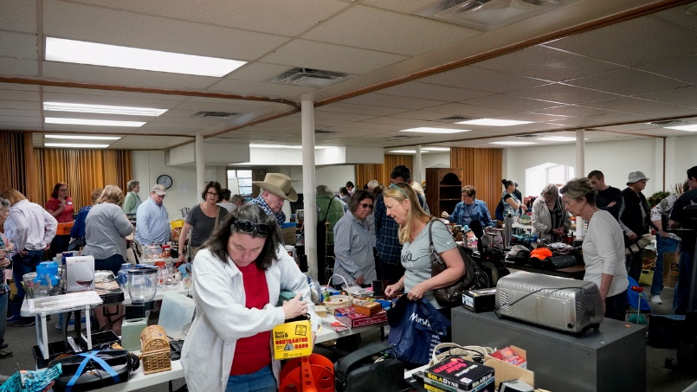
In April, the public enjoys attending our large Flea Market fundraiser. Hundreds of people stop in to our parish hall to browse, shop, or have bite to eat. The church raises an average of $2,000 annually from this event, and some items are donated to MOC.

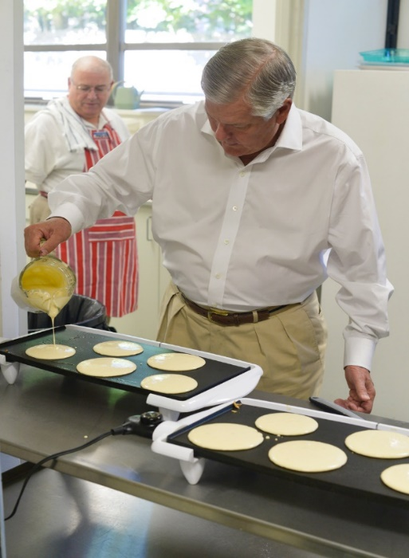
The Church invites a different charity twice a year to speak to our parishioners about their charity’s goals and mission. A delicious, homemade breakfast is provided, and a free-will offering is collected to donate to the charity.
C 025
4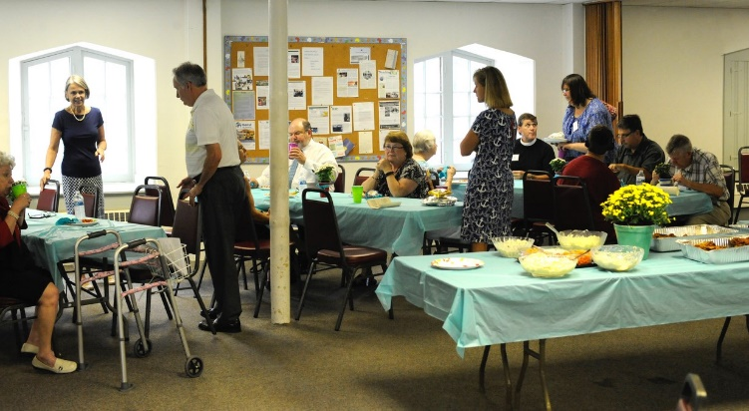

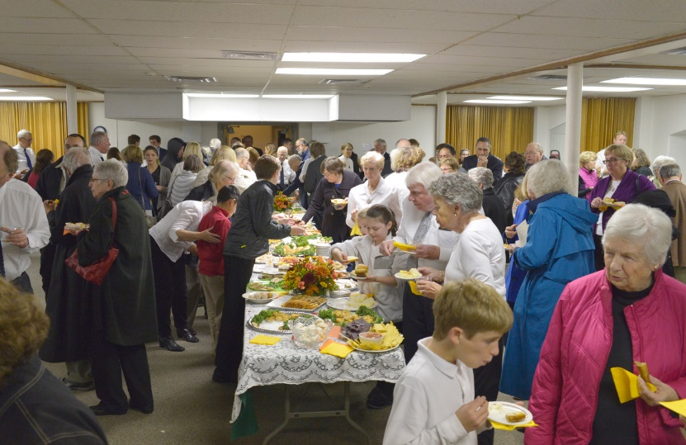
Finally, Green Hill enjoys an annual collaborative singing opportunity and reception. The choir joins with choirs from three other area churches for a Thanksgiving service/concert, hosted by the churches on a rotational basis. Besides Green Hill, the churches are Lower Brandywine Presbyterian, Christ Church Christiana Hundred, and St. Joseph on the Brandywine. Each minister/priest/pastor from these churches is invited to be a participant in some way during this special service.

At Christmas the Green Hill choir joins again with Lower Brandywine Presbyterian to present an oratorio or large choral work with small orchestra. Two performances are held during Green Hill and Lower Brandywine church services in December.

Church Fun
In addition to community involvement, the church believes in FUN! Many of these activities bring parishioners together, as well as provide opportunities to meet and to enjoy good fellowship. The pastor supports and attends many of these events. The Fellowship Committee organizes many activities including after church coffee or lemonade and conversation, special coffees and teas with sandwiches and desserts, the Christmas luncheon, new member receptions, etc. Other activities have included movie nights, talent shows, dinner groups, bowling party, baseball games, women’s Christmas gift exchange, Christmas caroling and chili supper, Easter egg hunts, cookouts, bell choirs, and pot luck suppers. Attendance for the above activities ranges from eight to 50 people.

Our Boards, Committees, and Staff
The Boards of Green Hill Presbyterian Church are:
Session: Six elected elders and a Moderator. The Session has the responsibility for governing the congregation and guiding its witness to the sovereign activity of God in the world. In particular the Session has the responsibility and power to:
- Provide that the Word of God may be truly preached and heard
- Provide that the Sacraments may be rightly administered and received
- Nurture the covenant community of disciples of Christ (per Book of Order G-3.0201)

The Committees of Session are Worship, Christian Education, Mission & Prayer, Fellowship, Personnel, Nominating, Investments, and Stewardship

Deacons: Six elected deacons who appoint their own moderator. Under the authority of the Session, the Deacons have a ministry of compassion, witness and service. In addition to supporting local missions, our Deacons oversee:
- Mother’s Day and Father’s Day gifts presented to the women and men of the congregation, respectively
- Care packages for the Troops
- Deacon Care List of Shut-ins and those in need, sending Holiday and birthdays cards, writing notes, and driving when needed
- Poinsettias and Easter lilies delivery to local nursing homes
- Transportation to and from worship, as requested
Trustees: Six elected trustees who elect their own president. Under the authority of the Session, the Trustees are responsible for the maintenance and operations of the church and its properties. The Trustees also serve as trustees of the Green Hill Cemetery Corporation.

Staff Position Descriptions
Green Hill has three paid staff positions: Pastor, Music Director, and Administrative Assistant. The Pastor is a full-time position. The Music Director serves as organist and pianist and is responsible for conducting the adult choir and the children’s choir, leading two bell choirs and hiring guest musicians as needed throughout the year. The Administrative Assistant is a part-time position and functions as the church receptionist and provider of secretarial services to the church officers and staff.
DESCRIPTION OF THE PARISH AREA
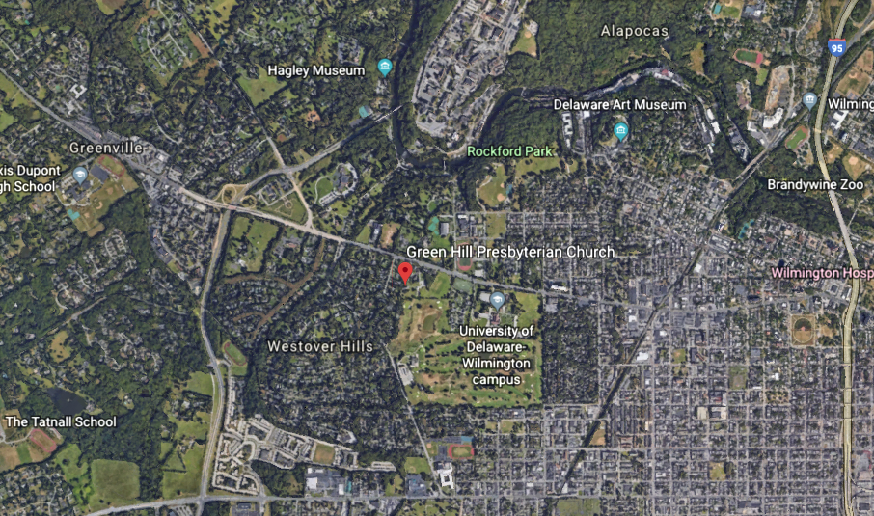
The church is situated just outside the city limits of Wilmington in northern New Castle County, Delaware. It is surrounded by established single-family residences, Tower Hill School (an independent school for pre-school through 12th grade), Ed Oliver Golf Course (a public 18-hole course), and the Wilmington campus of the University of Delaware. To the north is Greenville, Delaware, a community of several thousand people, which is 85% white, 7% Asian, and 5% African-American; the median age is 47 years, and one-fourth of the households have children under 18 living with them. Per capita income in this area is at the highest level in the state.

The adjacent area within the Wilmington City limits is also an established residential one, with about two-thirds of the residences being 70 or more years old. Again, the racial composition is largely white, with an increasing number of Hispanics and a stable or declining percentage of African-Americans. About one-third of the residents in this area have completed college or post-graduate studies.

OUR Community
The makeup of our congregation represents the diversity of our neighborhood. The city of Wilmington offers a variety of challenges including homelessness, addiction, violence, gang activities, etc. that some of our outreach efforts address.

Our history and Property (portions taken from the Green Hill Presbyterian Church Celebrates its One Hundred Fiftieth Anniversary 1849 – 1999 booklet)

Early Beginnings of Green Hill
Green Hill Presbyterian Church, founded in 1849, has a rich history. Nearly one hundred seventy years ago, a group of devout Presbyterians resolved to erect a house of worship in which they might congregate to glorify God. Generously, they gave of their time and money to see that this resolution was fulfilled.

The rudimentary beginnings of this house of worship began in the form of the “Brandywine Manufacturer’s Sunday School,” established initially by Robert Raikes at the DuPont powder mills along the Brandywine River around 1814. Mr. Raikes had founded the first Sabbath or Sunday Schools in England in 1780. The growth of factory production and powder mills brought more and more families to the Brandywine area. Immigrants, predominantly from Ireland and Scotland, began to fill the Sunday School for both worship services and as a place to learn to read and write. Worship in the Sunday School began somewhat as what we would today call “non-denominational,” since it had a healthy population of Methodists, Catholics, Episcopalians, as well as Presbyterians. In time, each denomination met separately for one hour of worship and catechism study. The ongoing success of the overall enterprise was due primarily to the dedication of Victorine du Pont and her management of the Sunday School for about 40 years.

Over the years, each denomination slowly began to gather its own flock and establish their own individual houses of worship. Besides Green Hill Presbyterian Church, other prominent Wilmington congregations stemming from Mr. Raikes’ original “Sabbath School,” include Christ Episcopal, Mount Salem Methodist, and St. Joseph on the Brandywine Roman Catholic churches.

The Cemetery
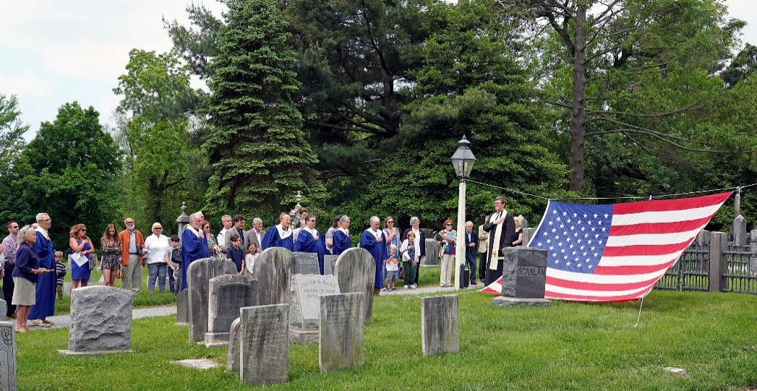
In 1847, a group of Presbyterians appointed a committee to procure a lot on what had been the Green Hill Farm, to be chartered as a cemetery. The property was incorporated under the Trustees of Green Hill Presbyterian Church. In the mid 1990’s, a Memorial Garden was created through a generous gift to the cemetery. Within the cemetery lies a Civil War Drummer Boy. There are approximately 1,100 souls at rest surrounding us, and our active cemetery helps us to be reminded of the meaning of our faith every time we walk to and from the church. We think of them as still with us as part of our church family.
The Church Building
On November 15, 1848, on the northern end of the property, the corner stone of the church edifice was laid, and in 1849 our church was organized with twenty-eight members. It is a wonderful example of the Presbyterian style of the times, with classic architectural design including the original tall steeple, lofty ceiling and tall windows. During the late 1890’s the interior of the church was entirely remodeled, where the gallery and box pews were removed and two side aisles were exchanged for a center aisle. It is seemingly “right-sized” – not too big and not too small - with pew seating for about 200. Many seasoned Presbyterians have said that it reminds them of the churches that they “grew up” in. The second remodeling of the interior occurred in 1933 with the removal of stained glass windows, which were replaced to that of plain translucent glass. The chancel was refinished with plain dark paneling. A new pulpit, lectern and communion table were installed through a gift by the Stirling family. The ambience is inspiring with lots of natural light and a physical layout that is comfortable. We are fortunate to have a working historic Hook and Hastings pipe organ to add grace to our services. A “pipe room” was built to house the pipes.

A New Building Fund was established in the 1950’s and contributions exceeded $70,000. Due to generous giving, a new building addition provided a kitchen, restrooms, Sunday School, and Nursery rooms on the ground floor; on the second landing, behind the sanctuary are the church office, conference room and library, and the pastor’s office. A two-person elevator was installed in 1957. On the ground level below the sanctuary is our “Fellowship Hall,” which is used for meetings and social activities and is made available as part of our community outreach. The building has air conditioning and a security system. For its age, the building was deemed to be in “good condition” (2014 engineering structural condition assessment). A Capital Campaign in the 1990’s provided funds for the restoration of the stucco on the exterior and replacement of the slate roof.
The Grounds
We are on three adjoining parcels in New Castle County, totaling slightly over 5 acres. There is plenty of parking (two paved lots) and a “pipe stem” access road that puts us about 100 yards back from Kennett Pike. A lighted church sign is visible from the main road. Our historic cemetery surrounds the church.
Other Property
We own a single family home on church property that is currently being used as a rental.
Outreach of Green Hill
The doctrine of Green Hill has remained steadfast since its inception. The faith of our fathers provided us with a strong foundation in our outreach and discipleship. The generosity of the congregation and friends of Green Hill has enabled the church to develop and maintain our house of worship and enable its use in support of our mission.
Some of the first noted mission work at Green Hill began in 1884 with the formation of the Woman’s Missionary Society, and in 1904 with the founding of the Men’s Brotherhood, the fore-runner of the Men’s Club. Following the church’s centennial year, the outreach of the church became more documented. The expansion of outreach grew in the mid-1900s with changes to the social climate. Foreign missionary support, chartering a Boy Scout troop, Christian organizations for young adults, supporting our Senior High students in doing mission work outside of the US and running a private daycare center at the church are but a few of Green Hill’s support and outreach. During the tumultuous 1960s of racial unrest and riots within the city, Green Hill endorsed the Home Builders Association’s policy on Open Housing and declared that no racial distinction be allowed for the use of church facilities, spiritual or material.
The well-known annual “Flea Market” at Green Hill began in 1970, and continues today.
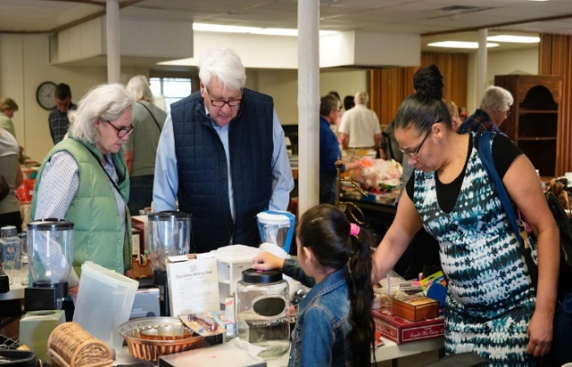
Not only does it function as a fundraiser, but also as community outreach.

The Board of Deacons has been instrumental with overseeing the church involvement in two community outreaches: Meals on Wheels (MOW) and Emmanuel Dining Room (EDR). In 1979, Green Hill became active in the MOW program and nearly 40 years later members of the congregation continue supporting this volunteer program. Green Hill also actively supports EDR after 36 years in its monthly meal preparation. The creation of Dinner Groups that meet for food and fellowship at member’s homes has remained strong after 27 years.
Renovation Project
The Green Hill Trustees have been working for over a year on a project to renovate Fellowship Hall and improve the restrooms. To date the project has not been finalized and approved by Session.

Technology
The website for Green Hill Presbyterian Church is www.greenhillpres.org. The website includes Church history and other current information, recent sermons, The SPIRE newsletter, upcoming events, directions, etc. The Church has a WIFI network and three computers: one for the pastor, one for the administrative assistant, and one used by the Treasurer and Assistant Treasurers for QuickBooks entries and reporting. A weekly email is sent to members and friends highlighting the upcoming Sunday service and other current activities in the life of the Church.
The printer/copier in the office also has scanning and fax capabilities. A television and DVR player are available for Bible study and Sunday School, and a projector is available for Movie Night or mission presentations.

FINANCIAL SUSTAINABILITY
The assets of the church are its property (described elsewhere) and its capital. Property is held in two corporations – the church and the cemetery. Each has an operating budget, with income and expenses, and an endowment. Since expenses are shared between the church and the cemetery, budgets are developed and approved by the Session, with input from the Trustees, who are the officers of the cemetery corporation. Income to the church is principally from member and non-member donations, gifts, donations from some that use our property (principally AA and Al-Anon groups), proceeds from a rental property and fund-raising activities. Income to the cemetery is principally fees for burials and gifts, and proceeds from lot sales are directed to a cemetery investment account.
At this time the cash balance for the church operating accounts is $92,000 and $12,000 for the cemetery account. Funds not used for current operations are in investment accounts, and the current balance in the church investment account is $821,000, and $117,000 is in the cemetery investment account. Both investment accounts are managed by an Investment Committee, consisting of the Treasurer and four others appointed by the Session; the function of the Committee is to invest the funds prudently, following guidelines on asset allocation approved by the Session. Funds are withdrawn, on Session direction, from both investment accounts to support current operations, the current transfer levels being less than five percent of principal annually. Church and cemetery funds are not comingled.
Looking ahead, we recognize that our historic property, which is heavily used, will likely require an increasing level of financial support to maintain and improve its condition. Previous major maintenance items (e.g., a roof replacement and exterior stucco renovation) were financed largely through donations. Our per-capita member giving has historically been at or near the top of levels in New Castle Presbytery, and we see no reason that will change suddenly. We are located in an established community, with little opportunity for any dramatic change in land use. Continued nominal withdrawals from the two investment accounts, coupled with hoped-for membership growth, should enable us to fulfill staff compensation and maintenance funding needs. Funds in the investment accounts are liquid, so backup is available should unforeseen events arise.

CONCLUSION
May God continue to bless the Green Hill family and the work that is done to glorify God.

APPENDIX
Note: Budgeted refers to Mission Committee Support through the operating budget, Benevolence refers to special offerings collected from the congregation and In Kind refers to non-monetary gifts, such as clothing, food, time and other tangible gifts.